The Greater Lincolnshire Public Service Compact Annual Report for 2016


Paul Collins, Director of Business Development at Boston College and Chair of the Public Service Compact Steering Group

The mission of the Compact is for public service organisations in Lincolnshire and Rutland to work together to address the particular employment / recruitment challenges that face the public sector in the two counties. These include;

- issues associated with recruitment and retention affected by rurality;

- low level of skills in some public sector organisations;

- difficulties in ensuring that the sector is responsive to the changing economic circumstances.

History

The Lincolnshire and Rutland Public Service Compact was established in 2007 to enable public service professionals to work together to address issues of common concern relating to training and recruitment. In the early years the Compact was instrumental in ensuring that all member organisations made a formal commitment to workforce development. The work has accelerated and member organisations are committed to increasing the number of Apprentices working in the public sector and facilitating partnership arrangements to develop collaborative approaches to issues of common concern and interest.

The Compact was funded by the LSC until March 2010. The work to develop the skills, knowledge and qualifications base of those working in public service has continued since then, with the Compact operating as a self-sustaining project. Funding has been secured from a variety of sources to ensure that the Compact continues to benefit from external support for its activities. These sources include one-off sponsorship arrangements, a Compact 'member organisation' subscription scheme and charging delegates from non-member organisations a small fee to attend good practice events.

Good Practice Events in 2016

Our Good Practice Events are well attended and feedback is overwhelmingly positive. Sponsorship and support from GMB Union, Lincoln College, Bishop Grossteste University and North Kesteven District Council allowed the Compact staged three Good Practice Events this calendar year:

The Changing Face of Apprenticeships addressed issues around the Apprenticeship Levy, sharing the very latest information along with existing good practice, as well as allowing organisations to examine how their own organisations would be affected.

Pay and Recognition in 2016 explored how the public sector can motivate and value employees in the face of budget cuts and pay restrictions. Whether the National Living Wage can be implemented without huge increases in the wage bill and how we can mitigate the effect on differentials. Also, whether it is possible to sustain employee morale and motivation without additional expense. Speakers addressed these themes from both an employment law perspective and a national union viewpoint. Two organisations (Nottingham City Council and Boston College) showcased their award-winning employee benefits schemes, demonstrating the cost-saving impact of morale boosting rewards.
Useful input on the future of public pay pressures.

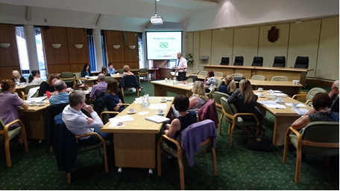

Some great slides and thought provoking content.

Excellent information from speakers and an opportunity to build bridges between organisations who are all facing the same challenges.

Good range of speakers. Good discussions and networking.

Connecting with the Millennials – recruiting the next generation looked at how we in the public sector can ‘grow our own’ workforce. The event examined questions such as: How can we attract young people to a career in the public sector? What about those who are not ready to take up an apprenticeship? Are traineeships and apprenticeships a real alternative to university? How can the latest developments in FE, HE and ‘on the job’ training help young people to progress into a rewarding career?
Good variation of presentations and information.

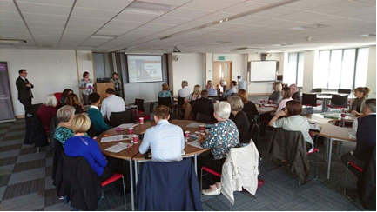

Interesting blend of content. Effective organistion from start to end.

My knowledge of the implications of the Apprenticeship levy was much improved. Good forum for discussion.

All the presentations were connected but not repetitive.

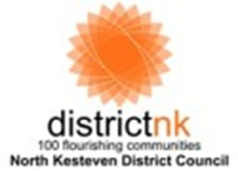
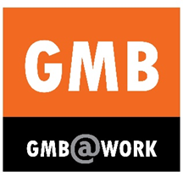
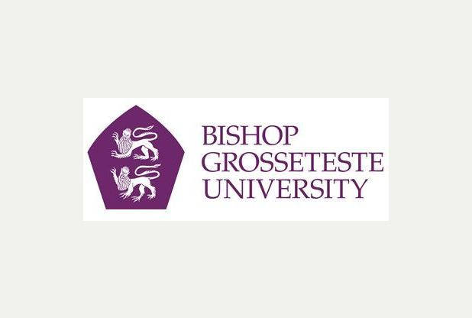



With support from the Compact we acquired funding from UNISON to support 12 further ‘Get on at Work’ events in public service settings in the East Midlands. This work was building on similar provision that was supported by the Compact in previous years. Through this project many individuals working in the public sector and its supply chain have been supported to address their identified basic skills issues.

******
On behalf of the Compact, facilitator attended the ‘Get Ready for the Levy’ event organised by the Skills Funding Agency for public sector organisations in the East Midlands in May. The materials from this event were disseminated to Compact members via email and the resources were published on the Compact web site.

Extra Value from the compact
Sourcing further additional support and funding for the sector

Over the last twelve months the Compact has worked hand-in-glove with the GMB ‘Engaging Young Workers’ project. The GMB project seeks to achieve a step change in the number of young people accessing job opportunities in the public sector and also develop materials to promote the sector in Lincolnshire. The Compact agreed to accept funding to provide the administrative support and management of their flagship event in the county – Connecting with the Millennials – recruiting the next generation. The event attracted 32 delegates and was very well received.
We organised two highly successful webinars on the subject of the Apprenticeship Levy. With the ‘drip feed’ of information coming out of BIS and the constantly changing picture, these enabled our members to keep up to date with the very latest developments.

Keeping our eye on the ball …

In order to disseminate key updates on issues that affect the sector the quarterly Steering Group meetings in 2016 accommodated, as a standing agenda item the following

- Education and Training Update (Paul Collins)
- The Employment and Skills Board Update (Amanda Boutell)
- Support for Apprenticeships and Traineeships (GMB colleagues)
- Support from Jobcentreplus (JC+ Colleagues)
- Working with the third sector (Fiona White)

Additionally the quarterly Steering Group meetings accommodated one-off presentations to disseminate information and current practice that would be useful to the membership.

Plans for 2017

The Compact will continue to work to support the Skills agenda of the Greater Lincolnshire LEP. This work will see the Compact promote the public service sector as an ‘employer of choice’ for young people. Additionally the Compact has an aspiration to work more closely with the Unions to support education and training at work. Thematic with the work with the Unions the Compact will undertake work in 2017 to increase the number of Apprentices in Public Service. It is likely that a major focus for the Compact will be to continue working together, where appropriate in partnership with the third sector, to deliver high quality public services in an austere environment. In 2017 the Compact is committed to deliver 4 good practice events to address issues of common concern and interest. The Compact will consider the impact of Brexit on the public service sector and respond appropriately.

Above all, the Compact is (and has always been) for the member organisations – by the member organisations. By subscribing in 2017 you will be instrumental in shaping the agenda for the Compact in the coming year.

As a Compact member organisation you will be entitled to

- Free delegate places at all good practice events in 2017
- Full membership of the Steering Group – a chance to shape the Compact agenda in 2017
- Full access to the Compact web site to share and download resources and access news items and the site’s document bank

Subscription Rates in 2016
£650 for organisations with over 500 staff
£325 for organisations with between 50 and 500 staff
£200 for organisations with less than 50 staff

Subscription Rates for 2017
£650 for organisations with over 500 staff
£325 for organisations with between 50 and 500 staff
£200 for organisations with less than 50 staff

NOTE: Subscription rates are held at the same level for the 6th year in succession

Our members in 2016:

Bishop Grosseteste University
Boston College
Lincoln College
City of Lincoln Council
East Lindsey District Council
Lincolnshire County Council
North Kesteven District Council
West Lindsey District Council
Community Lincs
Compass Point
GMB Union
UNISON
Jobcentre Plus
Greater Lincolnshire Public Sector Organisations – working together!
Lincolnshire Fire and Rescue
Lincolnshire Partnership Foundation Trust
Health Education England

We look forward to welcoming you as members for the coming year!

Paul Collins

Director of Business Development at Boston College and Chair of the Steering Group of the Public Service Compact

November 2016



